Sanday Report
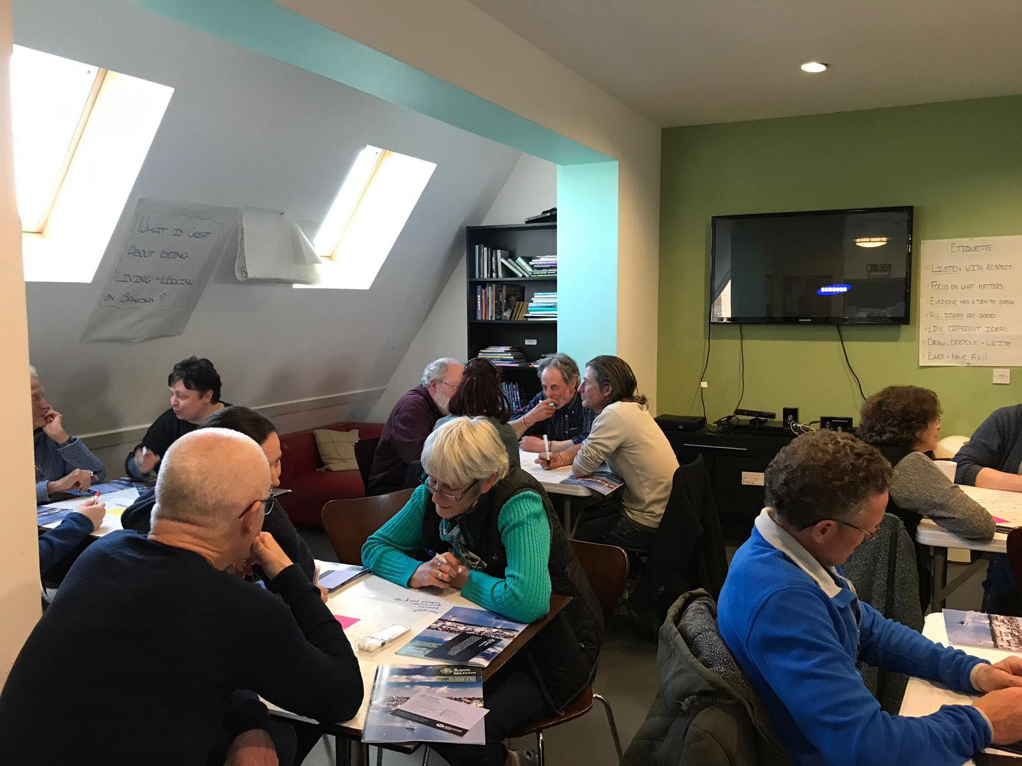

Island: Sanday
Date: 09/05/2019

This report has been produced by the Strathclyde Centre for Environmental Law and Governance (SCELG) and Scottish Islands Federation (SIF) in the framework of their collaboration with the Islands Team of the Scottish Government. The goal of this report is to capture the essence of the discussions that have taken place at the consultation event on Sanday. The report will be sent out to participants who authorised us to do so in order to receive further comments and feedback. The report is not to be considered as an indication of what will ultimately go into the National Island Plan, but it will inform the latter. The report is also not to be considered as an indication of the position of Scottish Government on any of the points mentioned therein.

Introduction
On 16th May 2019, a consultation event took place on Sanday. The event was attended by 17 people and the goal was to capture both what works well on the island and the challenges faced by the island community. The consultation is required by the Islands (Scotland) Act 2018, to inform the National Islands Plan that Scottish Government will be presenting to Scottish Parliament on 4 October 2019.

Sanday as a great place to live
The consultation highlighted the following things that make living on Sanday great:
- Sense of Community  - Low Population Density  - Peace and Quiet  - Safe and secure  - Nature  - Archaeology  - Healthcare  - Swimming Pool  - Interaction between age groups  - Farming  - Lack of pollution  - Education | 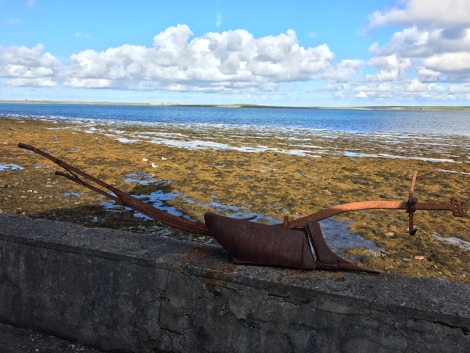
It is evident that there are many things that make Sanday a fantastic place to live. The list above only affords a glimpse, but it does highlight that there is a true sense of community on the island, that residents enjoy the nature and space afforded by living on the island, that the current level of education and healthcare is viewed as being good and that Sanday offers a safe and secure environment with very little crime. It should be noted that whilst the areas of employment and healthcare were mentioned as being a positive factor on the island, certain aspects of both were also noted as ‘challenges’ which are discussed in more detail below.

Challenges on Sanday
The consultation moved on to discuss the current challenges on Sanday and the main concerns of the island community. The following are the main issues that were shared by the participants at the event (see Annex for more details):
- Stopping Population Decline  - Economic Development  - Environmental Protection  - Health and wellbeing  - Community empowerment  - Transport  - Digital Connectivity  - Fuel Poverty  - Land Management  - Biosecurity  - Housing  - Increasing available activities | 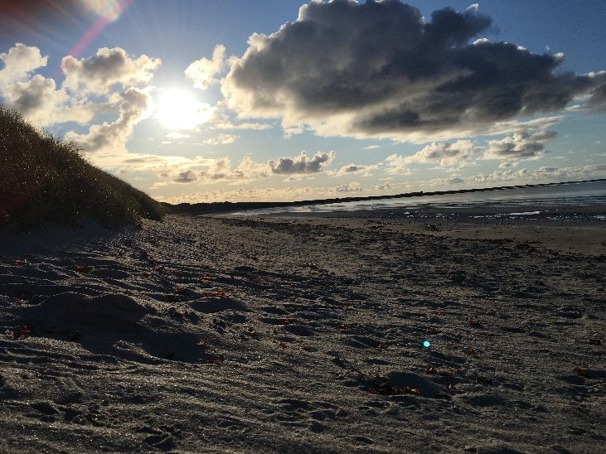

The National Islands Plan and the Response from the Participants
During the consultation, several key challenges were discussed in greater detail. We wish to make it very clear that a more in-depth focus was undertaken for the purposes of the face-to-face consultation and should not be considered as any indication of prioritization in the framework of the National Islands Plan.

The areas discussed more in depth were:
- Economic Development
- Environment
- Health and Wellbeing
- Transport

For each, participants were asked to provide more details about the challenge, their proposed solution, next steps, who should undertake these next steps and when. The following are the suggestions that we believe stemmed from the participants present at the consultation on Sanday:

Challenge | Suggestion from participants
Economic Development | - Recognise that boosting economic development on an island requires joint thinking with other policies such as, for example, housing, transport and digital connectivity.  - Explore funding options for business space and training that can promote the entrepreneurial potential of island communities.
Health and Wellbeing | - Link transport connectivity (timetabling) to the delivery of essential specialised health services on the mainland (Kirkwall)  - Explore the possibility of specialised health services visiting the island on a periodic basis.  - Boost funding for on island small scale projects that improve health and wellbeing, with a specific focus on mental health aspects.
Transport | - Revise current transport services with a focus on island community needs.  - Harmonise good practices related to the transport sector across all Scottish islands.  - Ensure that the new ferry and plane fleet are upgraded considering appropriate technology that specifically benefits the needs of island communities.
Environment | - Recycling:  - Development of an on-island recycling facility/scheme that promotes circular economy.  - Recognising the need for evidence based recycle policy and promoting on island recycling as a good practice from a circular economy perspective (recycle not just seen as an environmental issue but as an economic opportunity)  - Biosecurity  - Recognising the need for evidence-based decision making and stronger on island enforcement of such policy.  - Climate Change  - Challenge islands to lead the way in becoming carbon neutral (acknowledging that they are the most at risk & least responsible for climate change)  - Promote a range of measures that encourage green energy with a specific focus on domestic consumption (houses & cars)  - Environmental Awareness  - Support programmes both for schools & general public that promote a better understanding of the environment and the need to protect it.  - Support for organisations and services that deliver such works.

Sanday Vision
Island communities know that good governance requires an integrated and holistic approach to policy. We wish to stress once again that the National Islands Plan and its implementation will not address specific issues in isolation, but rather will consider all factors together whilst considering their crosscutting nature. In addition, each island has its own unique character and its own unique challenges. From the consultation on Sanday we have identified the following specific traits to Sanday:

Firstly, it is essential to note that when it comes to digital connectivity, the community on Sanday is not uniformly served, with some parts of the island enjoying good broadband and mobile connection and others much less. This was routinely mentioned as an ‘umbrella’ issue, that if improved would have ripple effects across the island. Specifically, the issue of economic development was highlighted as being severely impacted by the current lack of reliable connectivity, which has resulted in the full potential of remote working, and the possibility of those wishing to run their own business, not being fully realised on Sanday.

Secondly, although participants highlighted that current primary healthcare on the island was of a high standard, it became evident that access to secondary, physical & mental healthcare is lacking. This also emphasised the issues with current transport timetabling from the island, with a lack of cohesion between services meaning that medical appointments on the mainland are extremely difficult to attend. It is therefore essential that transport should not be considered just as an economic service, but as an essential lifeline for the community. For this to happen, both sectors need to be rethought having islands at the heart of the policy discussion. Consequently, timetabling, as well as ferry and air infrastructure, need to be revised in order to better benefit island communities.

Thirdly, it is evident that environmental concerns are crucial to the island community, and include recycling, biosecurity, climate change and improving environmental awareness. Consequently, there is a need to recognise the potential of islands to act as research hubs going forward, both in terms of going carbon neutral and the promotion of on island recycling as a good practice from a circular economy perspective – with the likes of recycling not just seen as an environmental issue, but as an economic opportunity that island communities could benefit from if afforded the proper support. This also require stronger policy and enforcement mechanisms to protect current biodiversity and raise the environmental awareness of both islanders and visitors.

What now?
First and foremost, we wish to thank those who attended the consultation events on Sanday. We encourage you to fill in the on-line consultation at https://consult.gov.scot/agriculture-and-rural-communities/national-islands-plan/. You can find the consultation document that provides background information about the Islands (Scotland) Act 2018, the National Islands Plan and the Islands Communities Impact Assessment at https://www.gov.scot/publications/national-islands-plan-islands-communities-impact-assessment-guidance-consultation/.

More importantly, please send us any comments/feedback on this report at n.crook@strath.ac.uk

The National Islands Plan will only be useful if it is truly informed by the island communities and by all those who have an interest and a stake in Scottish islands. Thanks to your participation in the consultation event and your comments and feedback, we are confident that the work being undertaken towards the National Islands Plan is capturing the voice of island communities. We are also sure that this is only the beginning and that, together, we can make sure that the National Islands Plan is not just “another” plan, but “The Plan” that works for island communities in Scotland.

Useful links:
- On-line consultation - https://consult.gov.scot/agriculture-and-rural-communities/national-islands-plan/
- Consultation document - https://www.gov.scot/publications/national-islands-plan-islands-communities-impact-assessment-guidance-consultation/
- Islands (Scotland) Act 2018
- Strathclyde Centre for Environmental Law and Governance (SCELG) - https://www.strath.ac.uk/research/strathclydecentreenvironmentallawgovernance/
- Scottish Island Federation (SIF) - http://www.scottish-islands-federation.co.uk/
- SCELG portal on the consultation - https://www.strath.ac.uk/research/strathclydecentreenvironmentallawgovernance/ourwork/research/labsincubators/eilean/islandsscotlandact/consultations/

Annex
Challenges about living and working on Sanday

-Depopulation  - Affordable housing  - Especially for young people  - Sheltered accommodation  - Support for people to integrate | -Economic Development  - Employment  - Not having to move away for work  -Especially for trades  -Retaining qualities of Sanday  -Tax 2nd homes  - No surcharges on parcel deliveries (and obligation to deliver) | -Transport  - New ferries, lower cost & joined up timetables  - Improve quality of service  - Ferry funding such as the Scottish Gov. provides in the Western Isles  - Boats with disabled access  - Joined up timetable with onward links  - More weekend flights & links to other Northern Isles
-Digital Connectivity  - Key service  - Must be faster & more reliable  - Better broadband  - Improved mobile signal | - Environmental protection  - Recycling waste management reduction  - Respect for the environment  - Better protection for wildlife & habitats plus better enforcement  - Recognition of climate change & risk to Sanday of sea level rise | -Health and wellbeing  - Elderly care
-Community empowerment  - Joined up decision making | -Fuel poverty  - Fair energy prices  - Cheaper fuel bills (especially electricity) | -Land management  - Geese are trouble
-Biosecurity  - No introduction of non-native species  - Control import of honeybees into Orkney  - No release of gamebirds | - Larger range of activities

