Covid-19 and Islands

Falkland Islands

- What actions are being taken to protect the island community from Covid 19? In particular, how are travel restrictions being put in place and enforced?

Respondent | Date | Response
Times Newspaper Article | 27 March 2020 | As Of 27 March  - The Falklands government has moved quickly to implement social distancing measures, telling schools and daycares to close and asking everyone but non-essential workers to stay home.  - The most vulnerable have been asked to stay in their homes for 12 weeks.  - Travel between the islands is now heavily restricted.  - anyone arriving in the Falklands from elsewhere must self-quarantine for 14 days.

- What actions will be taken should people on the island have Covid 19?

Respondent | Date | Response

- What actions are being taken to ensure that essential goods and services are provided to the island community?

Respondent | Date | Response

- What actions are being taken to ensure that people working on the islands, not only in the tourism sector, are sustained financially in the short term and in the long term?

Respondent | Date | Response

- What actions are being taken to ensure the mental well-being of people on the islands?

Respondent | Date | Response

- If you consider it appropriate, feel free to share any data about people who have Covid 19 on your island and of people who, sadly, have passed away because of Covid 19.

Respondent | Date | Response
Times Newspaper Article | 27 March 2020 | As of 27 March  - No confirmed cases but a child is critically ill with a suspected case

- Is there anything else you want to share?

Respondent | Date | Response
Times Newspaper Article | 27 March 2020 | See newspaper article on island risks and response here

- Resources

Resource and Date | Link
“Isolation Helped These Islands Delay a COVID-19 Outbreak. Now, Being Remote Could Be Their Biggest Problem”  Time  27 March 2020 | Read here

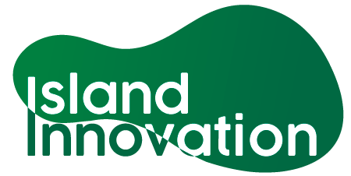

This information has been collated by the Strathclyde Centre for Environmental Law and Governance in collaboration with Island Innovation and can be found at https://www.strath.ac.uk/research/strathclydecentreenvironmentallawgovernance/ourwork/research/labsincubators/eilean/islandsandcovid-19/.

