Covid-19 and Islands

Maldives

- What actions are being taken to protect the island community from Covid 19? In particular, how are travel restrictions being put in place and enforced?

Respondent | Date | Response
Hafsath Aleem  CLEAN Maldives  info@cleanmaldives.org | 22 April 2020 | All Borders are closed and airport closed as well.

- What actions will be taken should people on the island have Covid 19?

Respondent | Date | Response
Hafsath Aleem  CLEAN Maldives  info@cleanmaldives.org | 22 April 2020 | Quarantine for 14 days.

- What actions are being taken to ensure that essential goods and services are provided to the island community?

Respondent | Date | Response
Hafsath Aleem  CLEAN Maldives  info@cleanmaldives.org | 22 April 2020 | Government has ensured that we have essential goods for at least 3 months if we have to go for a lockdown

- What actions are being taken to ensure that people working on the islands, not only in the tourism sector, are sustained financially in the short term and in the long term?

Respondent | Date | Response
Hafsath Aleem  CLEAN Maldives  info@cleanmaldives.org | 22 April 2020 | Government and Banks have given 6 months free to pay loans and Ministry of Trade and Economics will assist SMEs financially to sustain their businesses.

- What actions are being taken to ensure the mental well-being of people on the islands?

Respondent | Date | Response
Hafsath Aleem  CLEAN Maldives  info@cleanmaldives.org | 22 April 2020 | Awareness programs and educational information are circulated every day via TV and social media.

- If you consider it appropriate, feel free to share any data about people who have Covid 19 on your island and of people who, sadly, have passed away because of Covid 19.

Respondent | Date | Response
Hafsath Aleem  CLEAN Maldives  info@cleanmaldives.org | 22 April 2020 | So far a total of 85 are tested positive , 16 recovered

- If applicable, how are lockdown measures being relaxed?

Respondent | Date | Response

- Is there anything else you want to share?

Respondent | Date | Response
Hafsath Aleem  CLEAN Maldives  info@cleanmaldives.org | 22 April 2020 | We have a National Emergency Operation Center to work on the Covid 19. It includes Health Protection Agency (HPA), Maldives Red Crecent, Maldives National Defense Force, Maldives Police, Health Professionals, Volunteers and other frontline officers.

- Additional Resources

26 March 2020 | There are reports that governments are allocating specific islands into quarantine facilities. For example, see this report in relation to the Maldives.

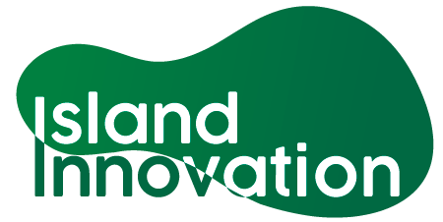

This information has been collated by the Strathclyde Centre for Environmental Law and Governance in collaboration with Island Innovation and can be found at https://www.strath.ac.uk/research/strathclydecentreenvironmentallawgovernance/ourwork/research/labsincubators/eilean/islandsandcovid-19/.

