Covid-19 and Islands

Sao Tome and Principe

- What actions are being taken to protect the island community from Covid 19? In particular, how are travel restrictions being put in place and enforced?

Respondent | Date | Response
Jyri Jontti  UNDP | 23 March 2020 | - All flights cancelled  - Last arrivals quarantined for 14 days  - Night clubs, schools and churches are closed, otherwise things continue as normal.

- What actions will be taken should people on the island have Covid 19?

Respondent | Date | Response
Jyri Jontti  UNDP | 23 March 2020 | - It is not clear yet, but copying the model of Portugal seems to have been the strategy this far.

- What actions are being taken to ensure that essential goods and services are provided to the island community?

Respondent | Date | Response
Jyri Jontti  UNDP | 23 March 2020 | - Portuguese providers have been contacted and they have ensured that they would keep on sending goods to the stores of Sao Tome and Principe. New activities are being crafted by multiple organizations, and money mobilized to up the production of sanitizers, protection equipment and support for the hospitals.

- What actions are being taken to ensure that people working on the islands, not only in the tourism sector, are sustained financially in the short term and in the long term?

Respondent | Date | Response
Jyri Jontti  UNDP | 23 March 2020 | - As of 23 March, nothing.

- What actions are being taken to ensure the mental well-being of people on the islands?

Respondent | Date | Response
Jyri Jontti  UNDP | 23 March 2020 | - Radio, TV and social media might have campaigns.

- If you consider it appropriate, feel free to share any data about people who have Covid 19 on your island and of people who, sadly, have passed away because of Covid 19.

Respondent | Date | Response
Jyri Jontti  UNDP | 23 March 2020 | - As of 23 March, no confirmed cases.

- Is there anything else you want to share?

Respondent | Date | Response

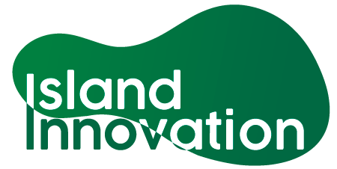

This information has been collated by the Strathclyde Centre for Environmental Law and Governance in collaboration with Island Innovation and can be found at https://www.strath.ac.uk/research/strathclydecentreenvironmentallawgovernance/ourwork/research/labsincubators/eilean/islandsandcovid-19/.

